Infosys Springboard Virtual Internship 7.0 Completion Report

Team Details
Batch 1
Start date: 29 June 2026
Names:
- Divya Bharathi I
- Guna Shekar Naidu Khandapu
- Jagadeesh
- Gopika Rajendiran
- Gilagalla Karthik
Internship Duration: 8 Weeks

1. Project Title
AI-POWERED INTELLIGENT SALES FORECASTING PLATFORM USING PREDICTIVE ANALYTICS

2. Project Objective
The objective of SalesGenie AI - An AI-Powered Intelligent Sales Forecasting Platform using Predictive Analytics is to streamline the sales workflow by combining lead management, lead intelligence, AI-powered outreach generation, lead scoring, conversation intelligence, CRM synchronization, and sales analytics in one platform. The project aims to reduce repetitive manual work, help sales teams prioritize promising prospects, and support faster, data-driven decisions.

3. Project description in detail
An AI-Powered Intelligent Sales Forecasting Platform using Predictive Analytics was developed as an integrated sales assistance platform. The system provides centralized lead management through manual entry and CSV import, with duplicate prevention based on email or company name. Lead information is used for company intelligence, AI-assisted outreach generation, lead scoring, conversation analysis, CRM synchronization, and dashboard analytics. The backend uses FastAPI, SQLAlchemy, and PostgreSQL, with REST APIs connecting the major modules. CRM integration was designed around Salesforce and HubSpot schema mapping. The frontend presents the workflows through an interactive web interface. In real-world use, the platform can reduce repetitive sales tasks, improve lead prioritization, maintain communication history, and provide a centralized view of pipeline performance.

4. Timeline Overview
Week | Activities Planned | Activities Completed
Week 1 | Requirements, project understanding and architecture | Requirements finalized; team roles and module plan established
Week 2 | Lead management and database foundation | Manual/CSV import, validation and deduplication implemented
Week 3 | Lead intelligence and company analysis | Company/prospect analysis workflow and APIs implemented
Week 4 | AI outreach generation | Personalized outreach generation and campaign workflow implemented
Week 5 | Lead scoring and recommendations | Lead scoring, classification and recommendation workflow integrated
Week 6 | Conversation intelligence | Conversation processing, summaries and interaction history implemented
Week 7 | CRM integration and synchronization | Salesforce/HubSpot schema mapping, sync APIs and logs implemented
Week 8 | Dashboard, testing and final integration | Dashboard APIs/UI, testing, integration and final demonstration completed

5a. Key Milestones
Milestone | Description | Date Achieved
Project Kickoff | Scope, requirements and team responsibilities established | 14.07.2026
Prototype/First Draft | Initial lead management workflow and backend foundation completed | 03.08.2026
Mid-Term Review | Major modules and APIs reviewed and integrated | 11.08.2026
Final Submission | Integrated project and documentation completed | 20.08.2026
Presentation | Final project presentation and demonstration | 21.08.2026

5b. Project execution details
The project was executed incrementally across eight weeks. The team first understood the requirements, defined the system architecture, and divided responsibilities across frontend, backend, AI/ML, database/DevOps, and QA. Lead management and the database foundation were implemented first. The team then developed lead intelligence, AI outreach, lead scoring, conversation intelligence, CRM synchronization, and the analytics dashboard. FastAPI endpoints were developed and tested through Swagger, while PostgreSQL provided persistent storage. Integration testing and debugging were performed throughout development, including validation of duplicate leads, API responses, synchronization behavior, and dashboard aggregation. The modules were finally integrated into one end-to-end workflow and demonstrated as a complete project.

6. Snapshots / Screenshots

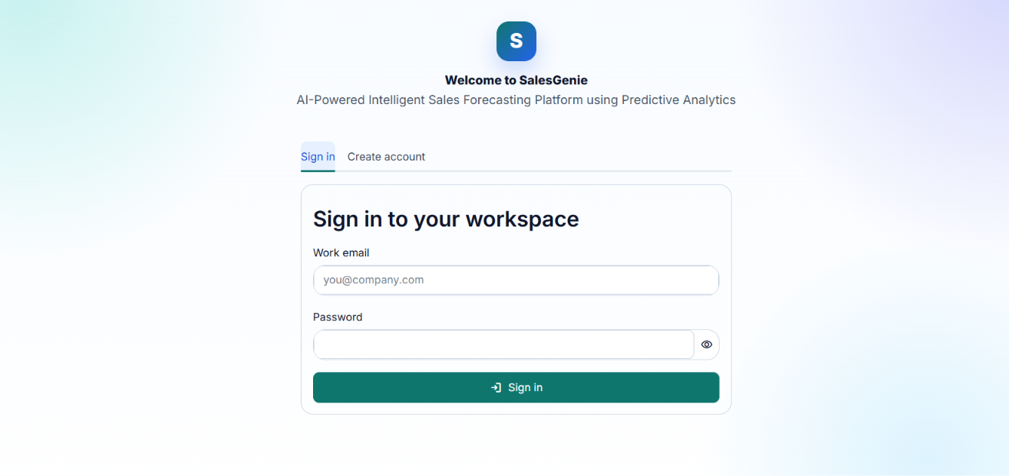
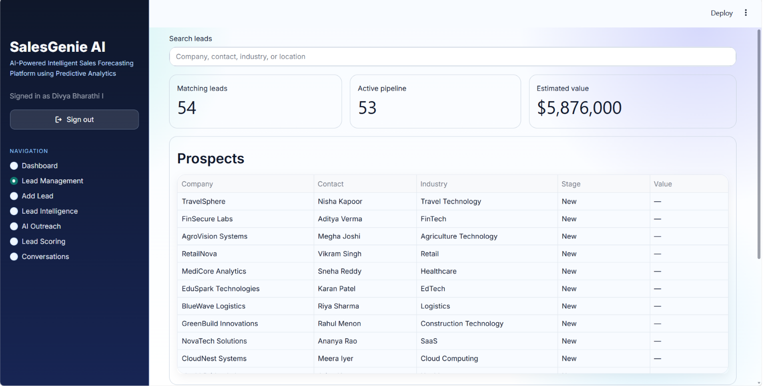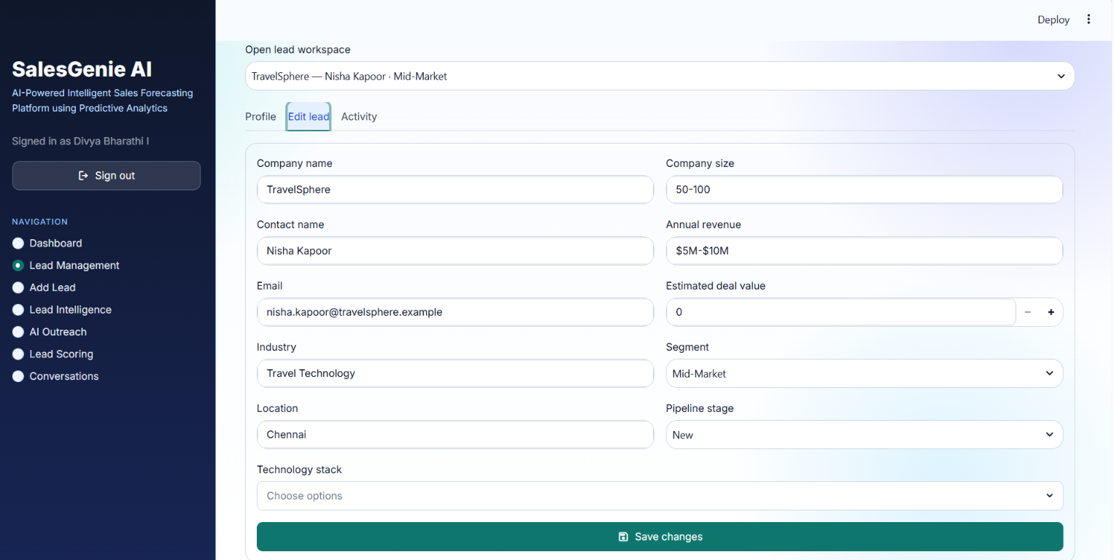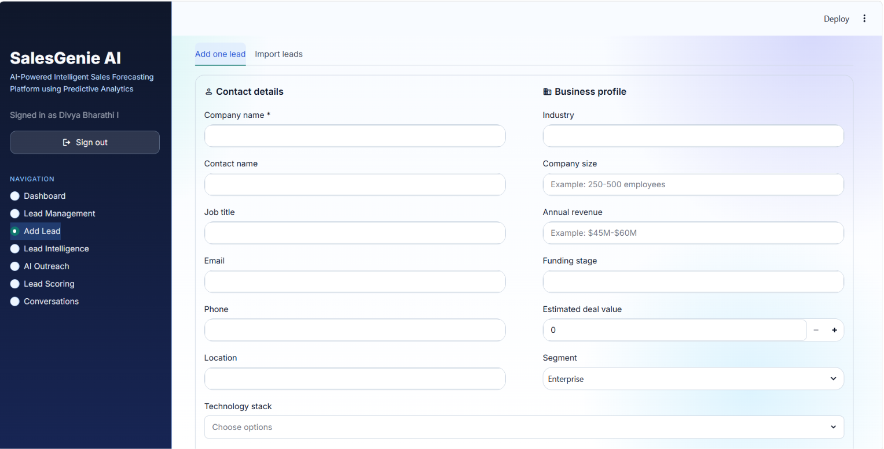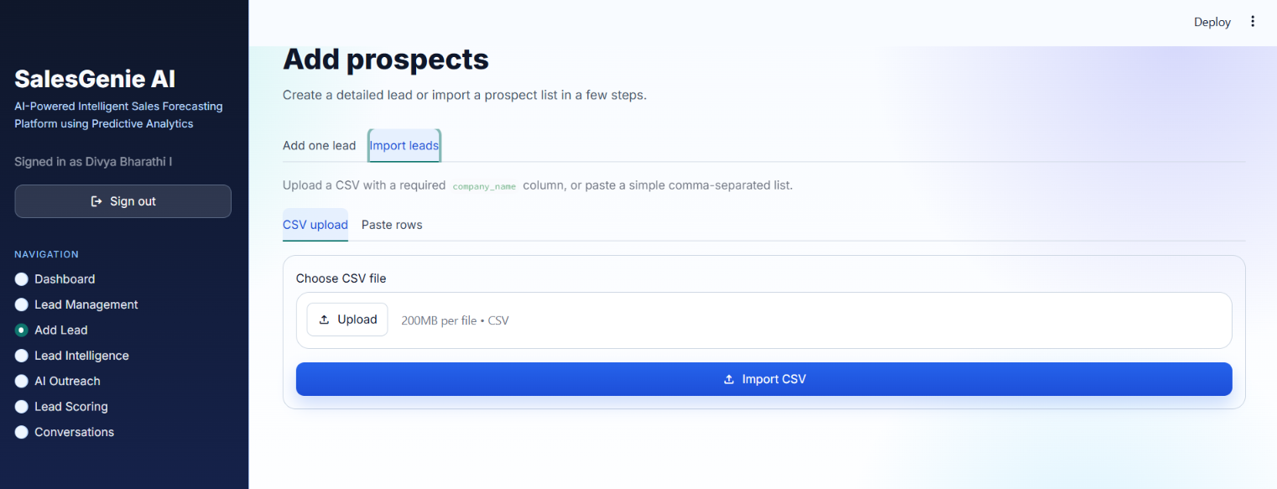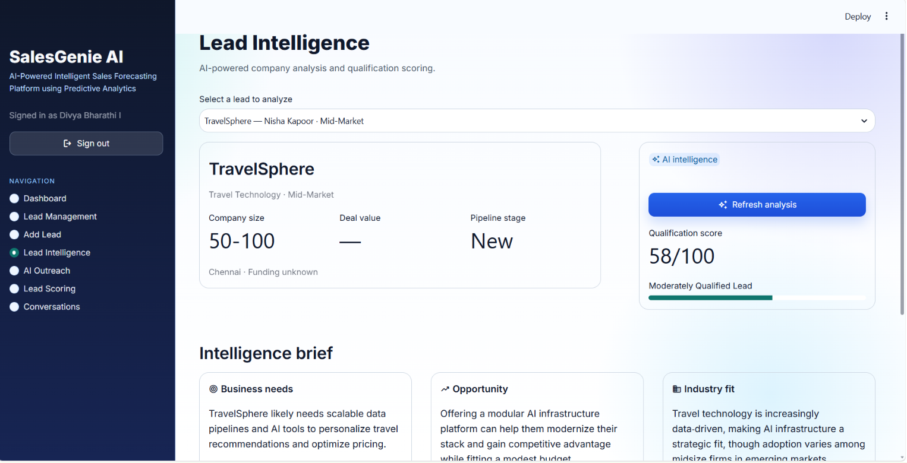
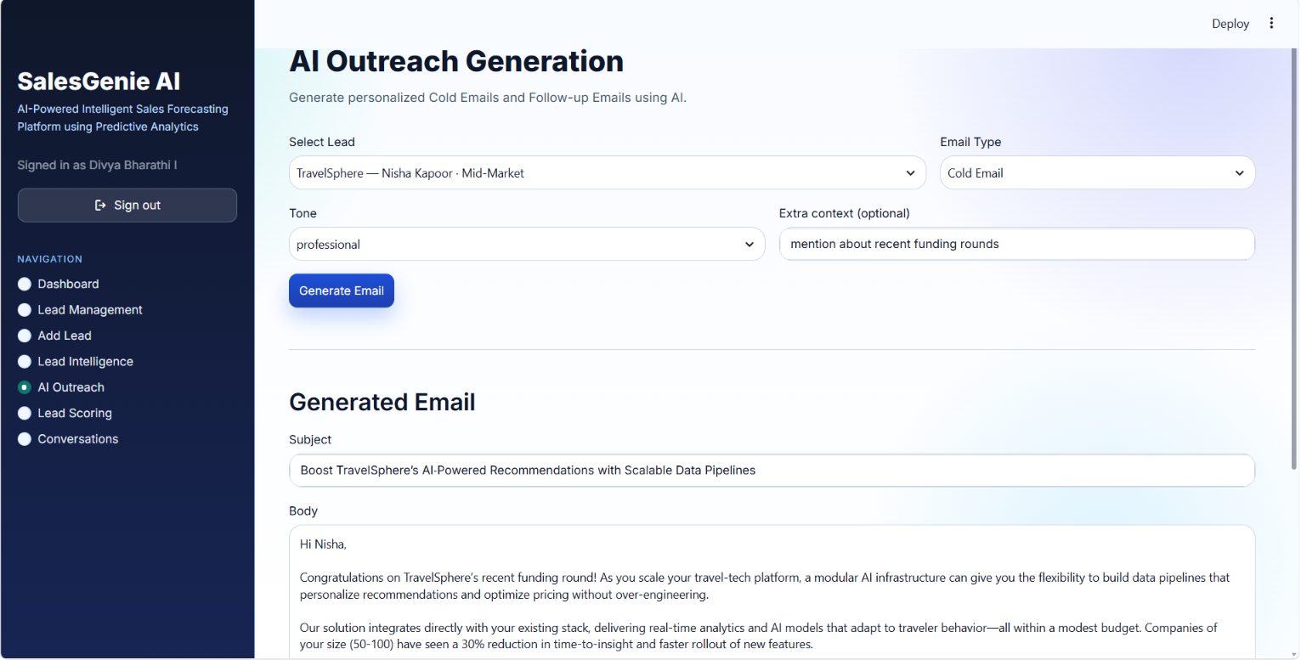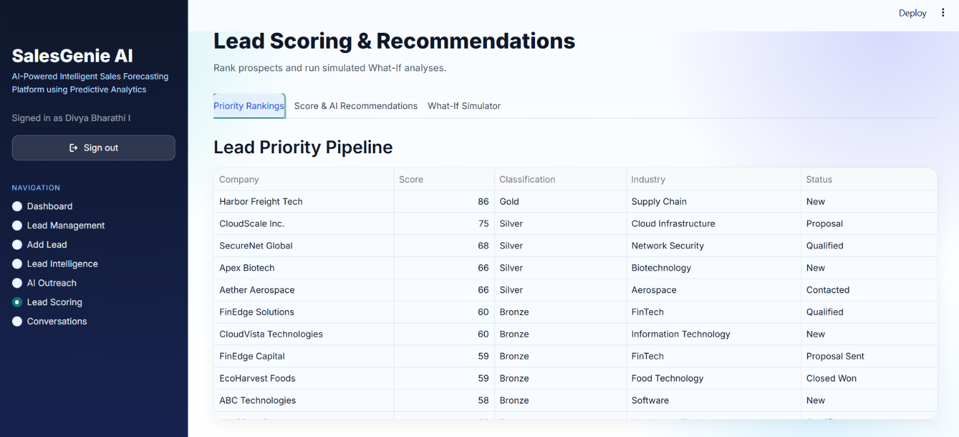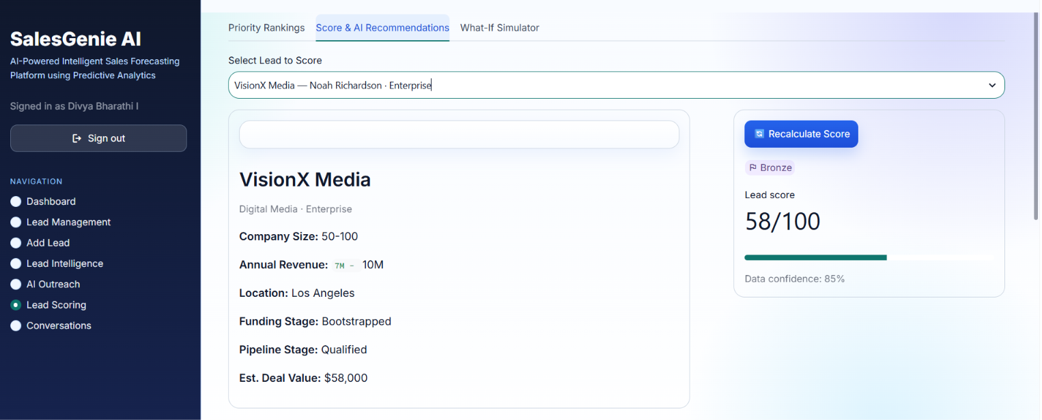

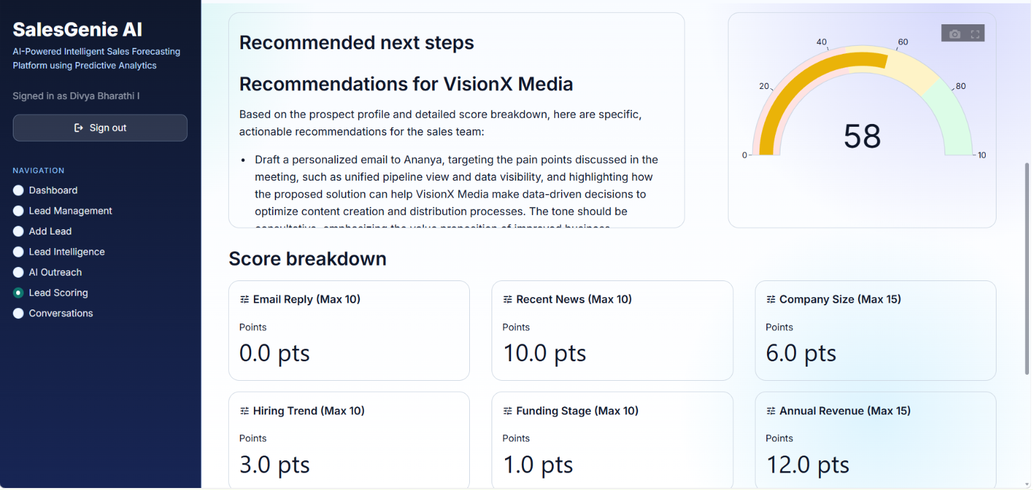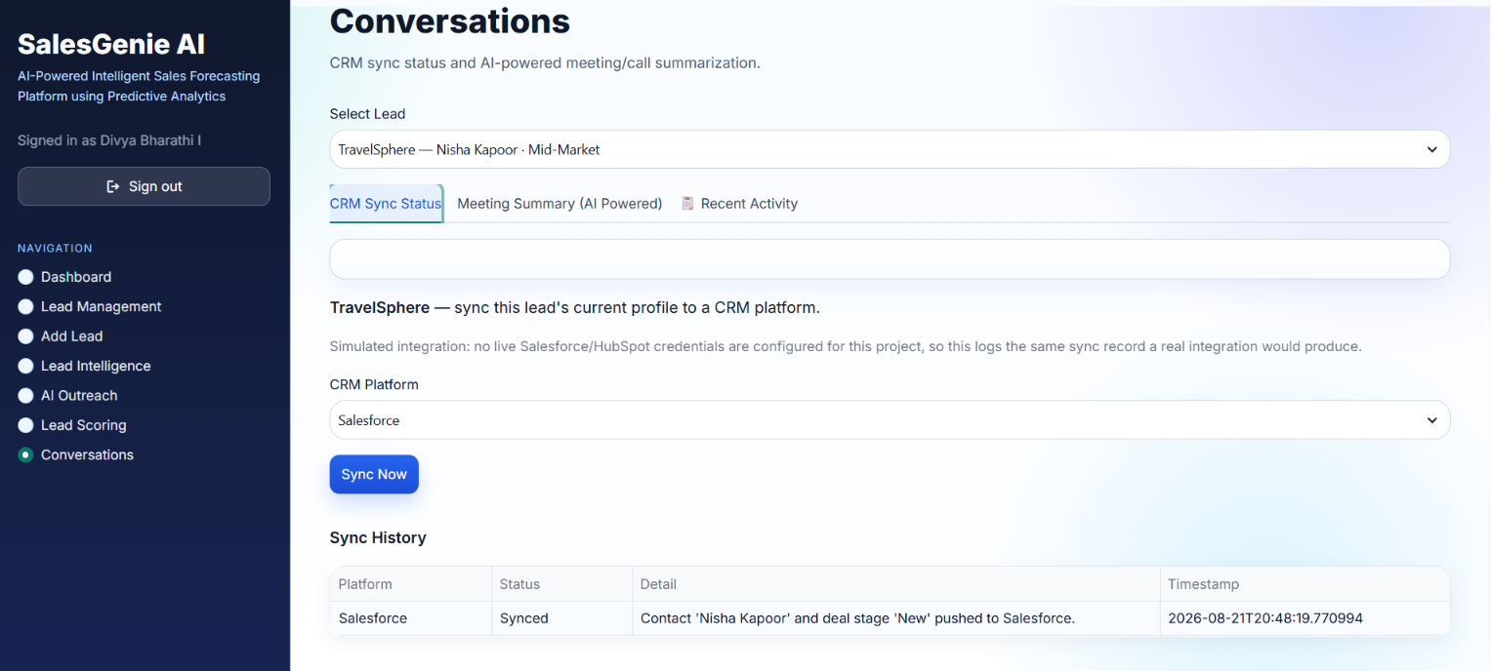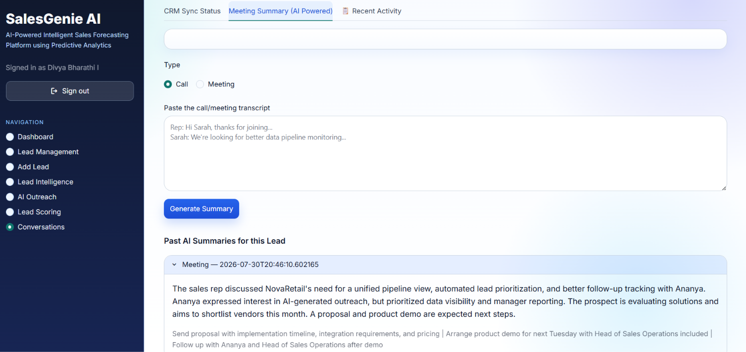
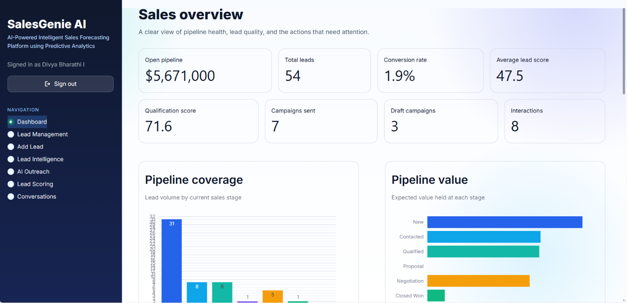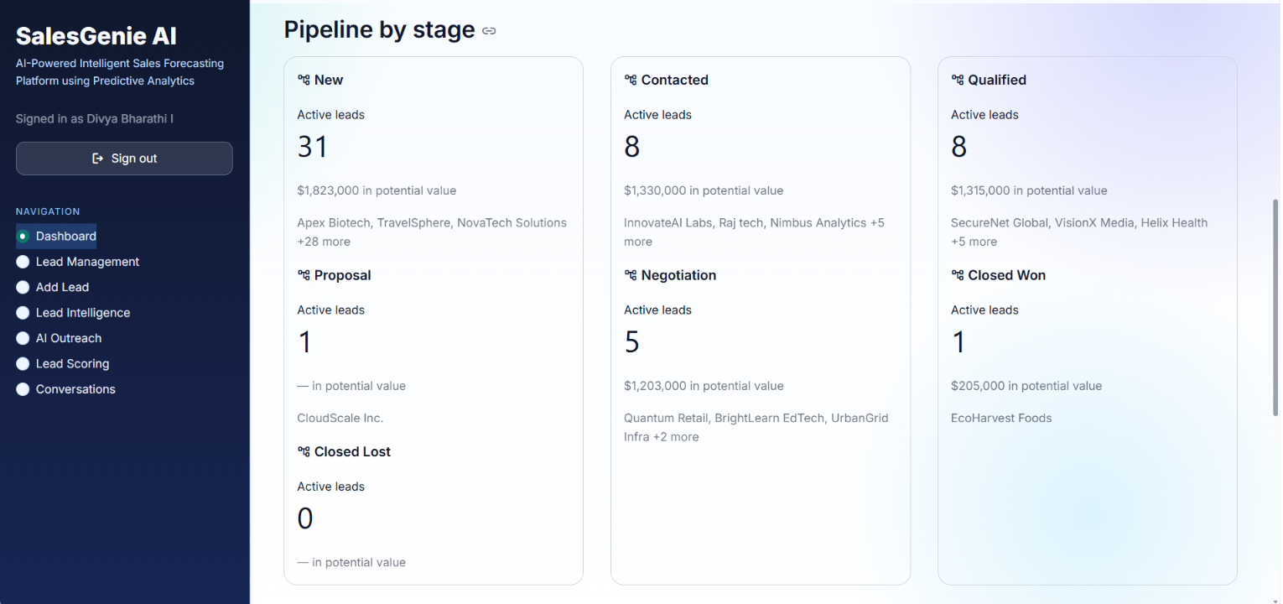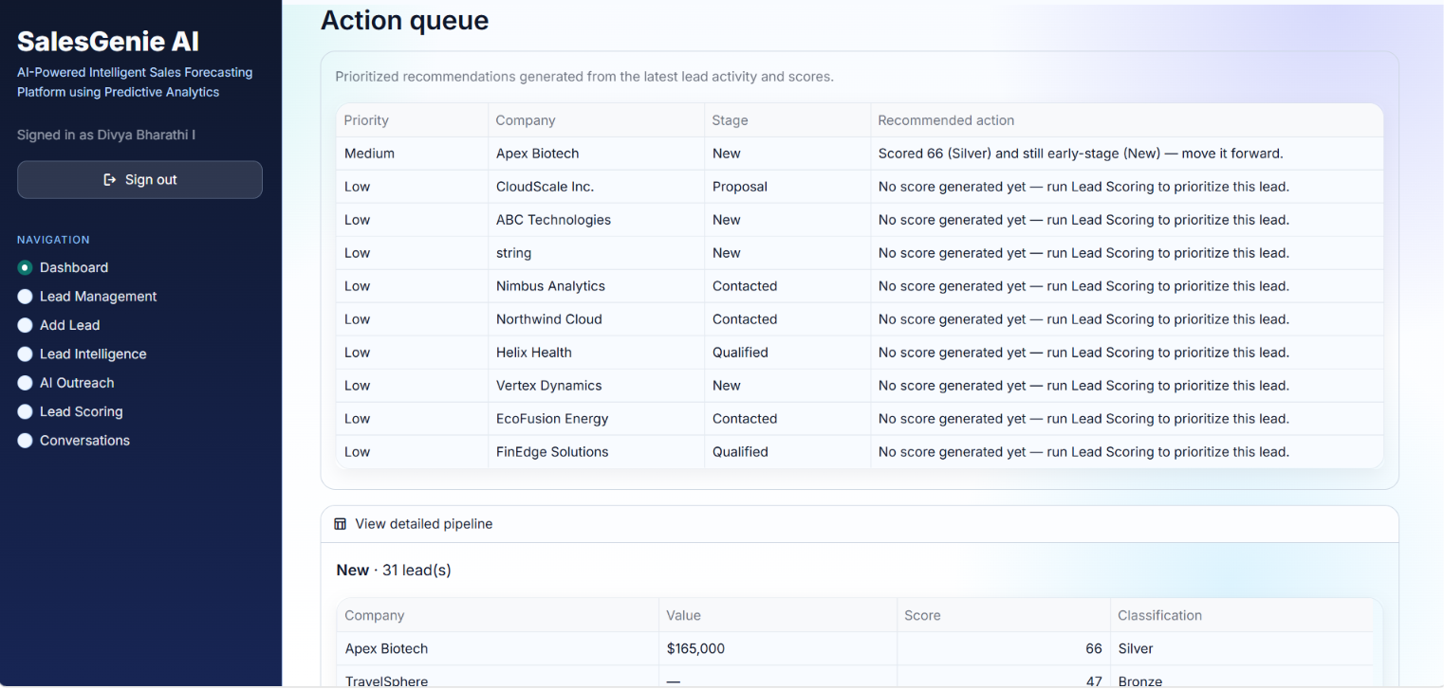

7. Challenges Faced
Major challenges included integrating multiple modules into a single workflow, keeping frontend, backend and database data consistent, preventing duplicate leads during CSV import and CRM synchronization, handling different CRM schemas, and debugging API integration issues. These were addressed through modular API design, input validation, deduplication checks, schema mapping, synchronization logs, systematic API testing, iterative debugging, and regular team coordination.

8. Learnings & Skills Acquired
The internship provided practical experience in FastAPI REST API development, PostgreSQL and SQLAlchemy, Swagger-based API testing, AI/LLM integration, CRM schema mapping, data validation, synchronization, and dashboard aggregation. The team also strengthened debugging, testing, Git-based collaboration, communication, leadership, time management, and technical presentation skills. The project provided practical exposure to applying AI and software engineering concepts to a real-world sales workflow.

9. Testimonials from team
Working as a five-member cross-functional team provided practical experience in developing and integrating a complete software application. We successfully combined frontend, backend, database, AI/ML, CRM integration, and testing activities into one platform. Regular collaboration, module-wise development, continuous testing, and mentor feedback helped us resolve integration issues and improve the project throughout the internship.

10. Conclusion
The internship provided valuable exposure to the complete software development lifecycle, from requirement analysis and architecture to API development, database integration, AI features, testing, and final integration. SalesGenie AI demonstrated how AI and backend technologies can automate sales workflows and support data-driven decisions. The experience strengthened our technical foundation and aligns with our academic learning and career interests in software engineering, backend development, AI, databases, and cloud-based applications.

11. Acknowledgements
We sincerely thank Infosys Springboard for providing this valuable learning opportunity and an industry-oriented project environment. We are grateful to our mentor for continuous guidance, feedback, and encouragement throughout the internship. We also thank all our team members for their collaboration, technical contributions, and support in completing this Internship journey.

